SOFTWARE DESIGN DOCUMENT(SDD)
Smart Ticket & Issue Management System
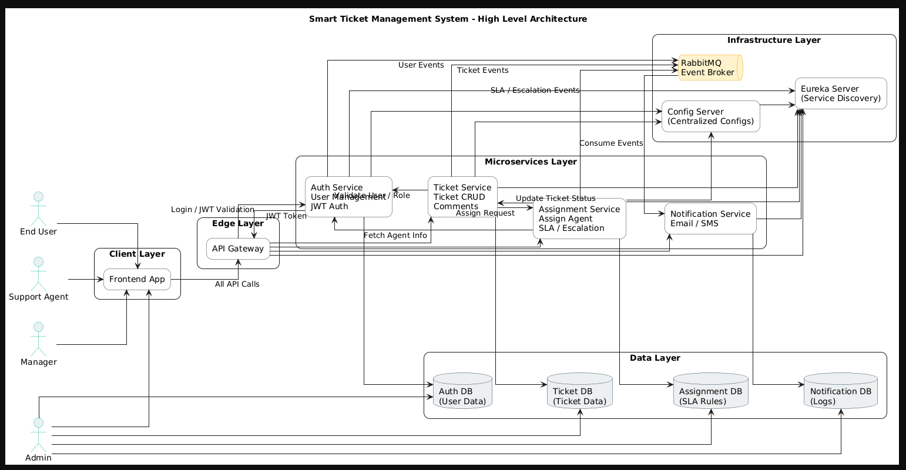
1. DOCUMENT CONTROL
Item | Details
Project Name | Smart Ticket & Issue Management System
Version | 1.0
Author | V.Lakshmi Varaprasad Reddy
Date | 29/12/2025
Status | Final
2. PURPOSE OF THE DOCUMENT
This document describes the system architecture, design decisions, component structure, APIs, data models, and non-functional aspects of the Smart Ticket & Issue Management System.
It is intended for:
- Developers
- Reviewers
- Interview discussions
- Maintenance & enhancement planning

3. SYSTEM OVERVIEW
Business Objective
Provide a scalable, secure, and maintainable system to:
- Manage Users & Identities
- Handle Ticket Lifecycle
- Ticket Allocation
- Support growth through microservices
High-Level Features

- User Registration & Secure Login
- Real-time Ticket Tracking
- Role-based access (USER / ADMIN / Manager / Agent)

4. ARCHITECTURE OVERVIEW (HLD)
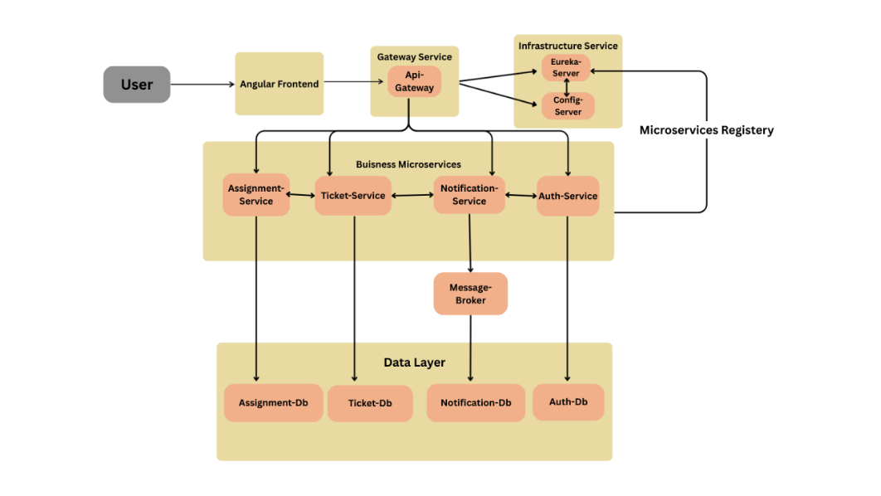
Architecture Style
- Microservices Architecture
- REST-based communication
- Containerized deployment
Core Components
- Angular Frontend
- Ticket Service
- Auth Service
- Assignment Service
- Notification Service
- MongoDB ,My Sql
5. TECHNOLOGY STACK
Backend
- Java 17
- Spring Boot
- Spring Web
- Spring Data MongoDB
- Spring Validation
Frontend
- Angular
- Angular Material
- RxJS
Database
- MongoDB & MongoDb
DevOps
- Docker
- Jenkins
- SonarQube
Testing
- JUnit 5
- Mockito
- Spring Boot Test

6. MICROSERVICES DESIGN
6.1 Auth Service
Responsibilities
- User registration and login
- JWT token generation and validation
- Role-based access control (RBAC)
- Password encryption (BCrypt)
- User session management

Key Entities

User
├── userId (UUID/Long)
├── username (String)
├── email (String)
├── password (Hashed)
├── role (ROLE_ADMIN, ROLE_MANAGER, ROLE_AGENT, ROLE_USER)
├── status (ACTIVE, INACTIVE)

Role
├── roleId
├── roleName

APIs

Method | Endpoint | Description | Request Body
POST | /auth/login | User login | {  "email":"string",  "password": "string"  }
POST | /auth/admin/register | Admin makes registrations | {  “username":"string",  "email": "string",  "password":"string",  “role”:”ROLE_XXX”  }
POST | /auth/register | Register | {  "username":"string",  "email": "string",  "password":"string",  }
GET | /auth/getAll | For admin side where he can all  (pagination added)
GET | /auth/user/{role} | Get users details by role | page, size, sortBy, direction all these will be passed in url type and  {“role”:”ROLE_X”}
GET | /auth/getEmail/{userId} | Get by userid for internal services | {  “userId”:”788263”  }
PUT | /auth/deactivate/{userId} | Deactivating and activating users | {  "useId":"string",  “request”:” activive/deactive”  }
PUT | /auth/user/{userId}/role | Role changing | {  "userId”:”23432”  “Role”:”enumroles”  }
 | /auth/logout | Logout user
  POST

Database
- auth_db (mysql)

6.2 Ticket Service
Responsibilities
- Ticket creation and lifecycle management
- Ticket status transitions
- Priority management
- Category management
- Attachments
- Ticket search and filtering
- Comments and activity tracking
Key Entities:
Ticket (MongoDB)
├── ticketId (ObjectId)
├── title (String)
├── description (String)
├── category (String)
├── priority ( HIGH, MEDIUM, LOW)
├── status (OPEN, ASSIGNED, IN_PROGRESS, RESOLVED, CLOSED,ESCALTED,BREACHED)
├── createdByUserId (String - User ID)
├── createdAt (Date)
├── updatedAt (Date)
├── assignedAgentID (String - Agent ID)

Comments
├── comments (returns list to front end)
├── commentId(uiid)
├── ticketId( string)
├── authorId(string)
└── text
├── isInternal(boolean)
└── createdat(Date)

attachments
├── Id
├── ticketId
├── filename
├── fileUrl
├── fileType
├── uploadedAt(date time)
└── uploadedby(string)

APIs
Method | Endpoint | Description | Request Body
POST | /tickets/create | Create new ticket | {  "title": "string",  "description":"string",  "category":"string",  "attachments": ["url1", "url2"]  }
GET | /tickets/getAllOpenTickets | Get All open tickets for assignment | -
PUT | /tickets/{ticketId}/status | Update ticket status | Request:  {status }
GET | /tickets/{userId}/getTickets | Get user tickets by id | -
GET | /tickets/{agentId}/getAgentTickets | List tickets of agents
GET | /tickets/{agentId}/getAgentResolvedTickets | Get agent resolved tickets
GET | /tickets/getAllTickets | Get all tickets
PUT | /tickets/{ticketId}/updateAgentId | Change ticket status | Request:  {  “Ticketid”:”2342”,  “agentId”:”2345”,  “priority”:”HIGH”  }
POST | /tickets/{ticketId}/comments | Add comment | Request:  {  "content": "string",  "isInternal": true  }
GET | /tickets/{ticketId}/getComments | Get comments
GET | /tickets/attachments/view/{attachmentId} | View ticket
GET | /ticket/{ticketId}/getTicket | Get on specific ticket
GET | /tickets/{ticketId}/attachments | Get attachments
GET | /ticket/my/dashboard | Get on his performance

Database
- Ticket System (MongoDB)
6.3 Assignment Service
Responsibilities
- Manual ticket assignment to agents
- Escalation handling
- Skill-based routing
- Workload balancing
- Reassignment management
- Get sla status of agents

**Assignment (MySQL)**

├── assignmentId (UUID)

├── agentId (String - Agent ID)

├── assignedAt (Timestamp)

├── assignedBy (String - User ID of Manager/Admin)

├── priority (HIGH, MEDIUM, LOW, CRITICAL)

├── status (ACTIVE, INACTIVE, REASSIGNED)

└── ticketId (String - Ticket ID)

SLA (MySQL)

├── sla_id (UUID)

├── assignment\_id (UUID - Foreign Key)

├── ticket\_id (String - Ticket ID)

├── response\_deadline (Timestamp)

├── resolution\_deadline (Timestamp)

├── responded\_at (Timestamp)

├── resolved\_at (Timestamp)

├── created\_at (Timestamp)

├── escalated (Boolean)

└── breached (Boolean)

SLA\_Event (MySQL)

├── eventId (UUID)

├── agentId (String - Agent ID)

├── assignmentId (UUID - Foreign Key)

├── eventType (RESPONSE, BREACHED)

├── occurredAt (Timestamp)

├── remarks (String - Details of the event)

└── ticketId (String - Ticket ID)

SLA_Rule (MySQL)

├── rule_id (UUID)

├── active (Boolean)

├── priority (String - HIGH, MEDIUM, LOW, CRITICAL)

├── resolution_hours (Integer)

├── response_minutes (Integer)

APIs
Method | Endpoint | Description | Request Body
POST | /assignment/assign | Assign ticket to agent | Request:  {  "ticketId":"string",  "agentId": "string",  “priority”:”enum”  }
GET | /assignment/agents/{agentId}/workload | Get workload on a agent | -
GET | /assignment/manager/workload | See all workloads | -
POST | /assignments/reassign | reassignment | {“ticketId”:”string”,  “agentId”:”string”}
PUT | /assignments/internal/sla/update-from-ticket | Sla updates by scheduler | {“ticketId”,”string”,”status”:”enum”}
GET | /assignments/internal/{ticketId}/getManagerId | For getting manager id
GET | /sla-events | Get All Slas
GET | /sla-events/agent/{agent-Id} | Get SLA on paticular

Database
- assignment collection (mysql)

6.4 Notification Service
Responsibilities
- Email notifications
- Event consumption
- Status change notifications
- Escalation alerts
- User notifications
- Message queuing via RabbitMQ

Key Entities:

Notification

├── notificationId (UUID)

├── createdat (Timestamp)

├── error_message (String - optional)

├── event_type (String - TICKET_CREATED, STATUS_CHANGE, ASSIGNMENT, ESCALATION, SLA_BREACH)

├── message (String - Full content of the notification/email body)

├── recipient_email (String)

├── status (String - PENDING, SENT, FAILED)

└── subject (String)
Database
- notification collection (mysql)

6.5 Api Gateway
Responsibilities
- - JWT Validation
- - Request/Response Logging
- - CORS Configuration
Routes:
- /auth/** → AUTH-SERVICE (9092)
- /tickets/** → TICKET-SERVICE (9093)
- /assignments/** → ASSIGNMENT-SERVICE (9094)

All services passes through API-GATEWAY(9091)

6.6 Eureka Server
Responsibilities:
- Service configuration
6.7 Config Server
Responsibilities:
- Centralized configuration
- Git repository for storing property files
- Supports multiple profiles
Admin Endpoints
Note - all admin endpoints are listed in the normal end but due to role based acces they differ.

7. DATA DESIGN (LLD)
User Document

"user_id": "u101",
"email": "user@test.com",
"is_active": true,
"name": “abc,
"password": "encrypted",
"role_id": "USER"
}

Ticket Document
{
"_id": "6957d6d90586d2f0f797d492",
"title": "Motot issue",
"description": "User is unable to get values",
"category": "HARDWARE",
"priority": "LOW",
"status": "ASSIGNED",
"createdByUserId": "0cf3922d-928a-4891-998f-bf4943ccedc0",
"assignedAgentId": "25ef5920-dc01-4fc9-8537-237e3288613f",
"createdAt": "2026-01-02T14:31:53.695+00:00",
"updatedAt": "2026-01-05T22:08:58.556+00:00"
}
Attachments Document
{
"id": "6957dba40586d2f0f797d499",
"ticketId": "6957dba40586d2f0f797d497",
"fileName": "bill2.pdf",
"fileUrl": "storage\\tickets_attachment\\a8f0aca7-9beb-4639-b419-b8b58a1d5808_bill2.…",
"fileType": "application/pdf",
"uploadedBy": "0cf3922d-928a-4891-998f-bf4943ccedc0",
"uploadedAt": "2026-01-02T14:52:20.955+00:00"
}
Comments Document
{
"_id": "6957d6530586d2f0f797d491",
"commentId": "8861efd2-f104-452c-ac37-e9d4c22c4ec1",
"ticketId": "6957d5ae0586d2f0f797d490",
"authorId": "bbbd3d37-99be-4a69-837e-4ed5c00fd54b",
"text": "Added the first comment",
"isInternal": true,
"createdAt": "2026-01-02T14:29:39.695+00:00",
}

Assignment Document
{ "assignment_id": "0b3c0f6f-b691-4523-b163-eb8f3f428ef0",
"agent_id": "25ef5920-dc01-4fc9-8537-237e3288613f",
"assigned_at": "2026-01-06 23:20:57.101099",
"assigned_by": "220bc5fa-14cc-4fcb-aa8e-7c08de825fb2",
"priority": "MEDIUM",
"status": "ACTIVE",
"ticket_id": "695d3a017f2fb68d3aacd2f4"
}
Notification Document
{
"id": "N1001",
"emailId": "abc@gmail.com",
"error_msg": "",
“Event_type”:”queue name”,
“Message”:”string”,
“subject”:”string”,
“status”:FAILED/SENT
"created_at": "Time Stamp"
}
}

8. API DESIGN & VALIDATION
- RESTful principles
- JSON request/response
- Bean Validation at DTO layer
- Service-level business rule enforcement
- Standard HTTP status codes

9. ERROR HANDLING STRATEGY
Global Exception Handling
- Centralized using @ControllerAdvice
- Standard error response format
{
"timestamp": "TimeStamp",
"status": 400,
"error": "Validation Error",
"message": "Invalid Ticket Data"
}

10. SECURITY DESIGN
- Password encryption (BCrypt)
- Role-based access control
- JWT authentication
- Secure API access

11. NON-FUNCTIONAL REQUIREMENTS
Area | Design Decision
Scalability | Stateless services, Docker
Performance | Pagination, async calls
Availability | Independent services
Maintainability | POM-like layered backend
Security | Validation, encryption
Observability | Logging & monitoring

12. TESTING STRATEGY
Backend
- Unit tests (Service layer, controller layer)
- Controller tests (MockMvc)
Quality Gates
- SonarQube enforced
- Build fails on violations

13. CI/CD DESIGN

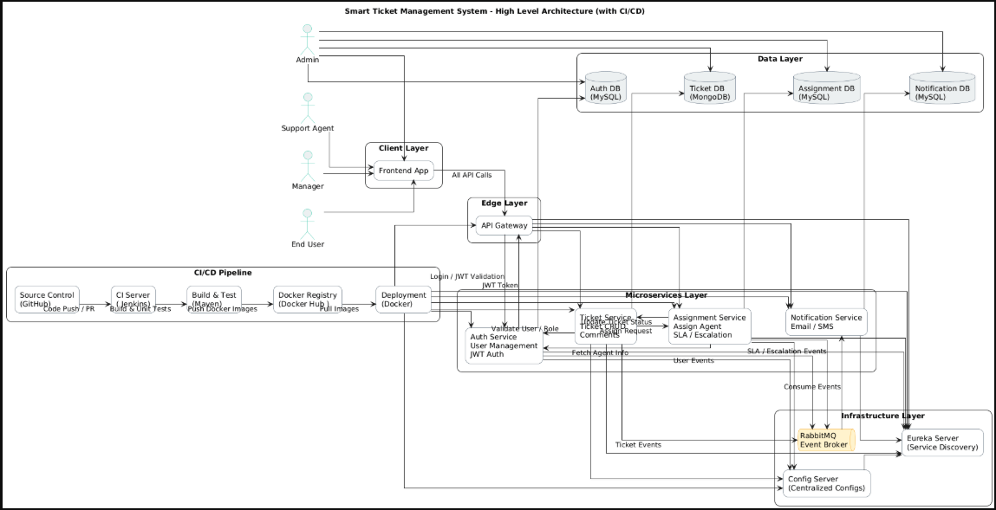

Pipeline Flow
- Git Commit
- Jenkins Build
- Unit Tests
- SonarQube Scan
- Quality Gate Check
- Docker Build
- Docker Compose Deploy

15. ASSUMPTIONS & CONSTRAINTS
Assumptions
- Infrastructure Availability: It is assumed that the hosting environment (Docker Engine) provides sufficient CPU and RAM (minimum 8GB) to run 7+ concurrent Java microservices and 4 database instances.
- External Service Uptime: Third-party services, Gmail SMTP for notifications, are assumed to have a 99.9% uptime.
- Continuous Availability of CI/CD: The Jenkins server and SonarCloud are assumed to be accessible whenever a code push occurs to the GitHub repository.
Constraints
- Data Storage: Persistent data must be split between MYSQL (relational/identity data) and MongoDB (unstructured ticket metadata).
- Security Protocol: All microservice communication and end-user access must be secured using JWT (JSON Web Tokens) and role-based access control (RBAC).
- Asynchronous Messaging: All event-driven communication (e.g., ticket assignments, notification triggers) must utilize RabbitMQ as the message broker.

16. FUTURE ENHANCEMENTS
- Sentiment Analysis: Implement NLP models to analyze the tone of incoming tickets. High-priority alerts can be triggered if a customer’s sentiment is detected as "frustrated" or "urgent."
- AI Smart Routing: Replace rule-based assignment with machine learning models that route tickets based on an agent’s historical resolution speed and success rate for specific issue categories.
- Auto-Summary: Use LLMs (Large Language Models) to generate a concise summary of long ticket threads for managers during shifts or escalations.

17. CONCLUSION
This design ensures:
✔ Clean separation of concerns
✔ Scalability & maintainability
✔ Testability & CI/CD readiness

SEQUENCE DIAGRAMS
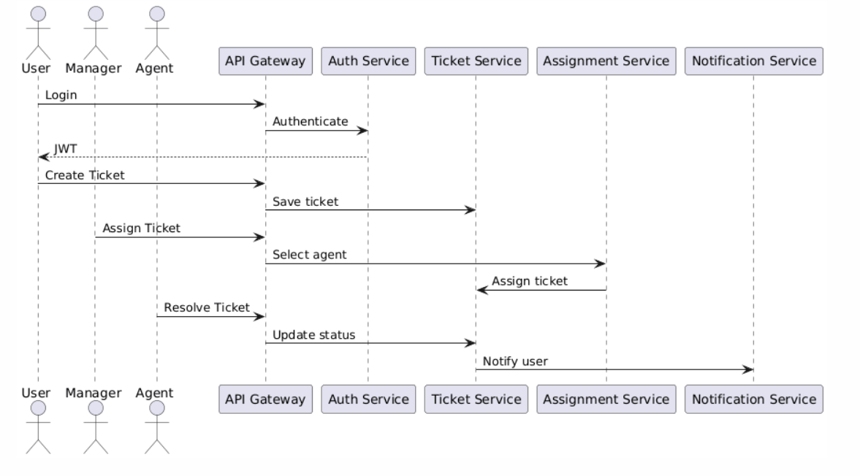

User Login Flow -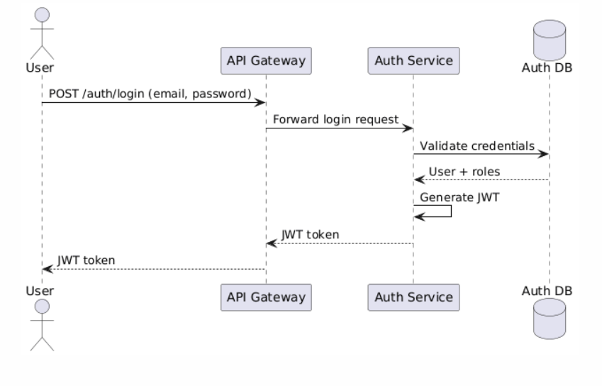
Ticket Creation -
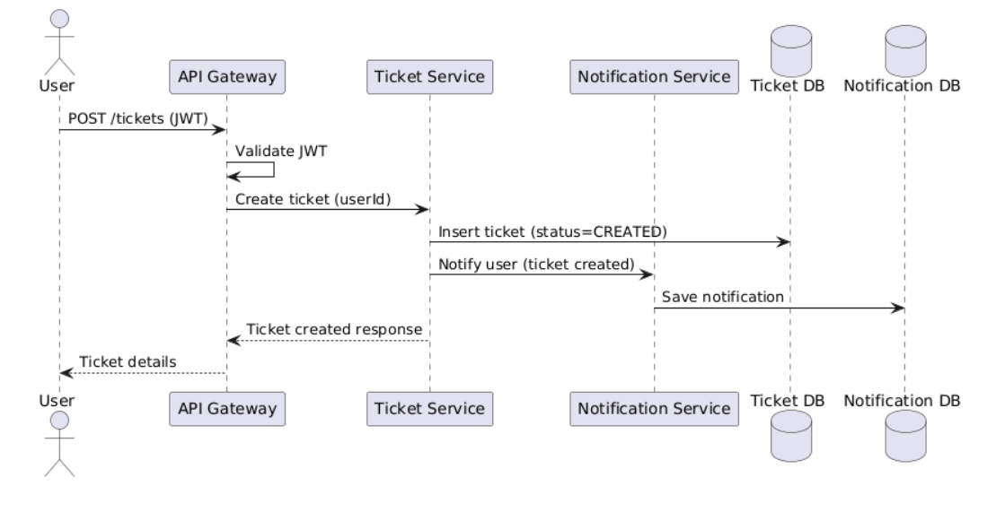

Manager Assigns Ticket to Agent -

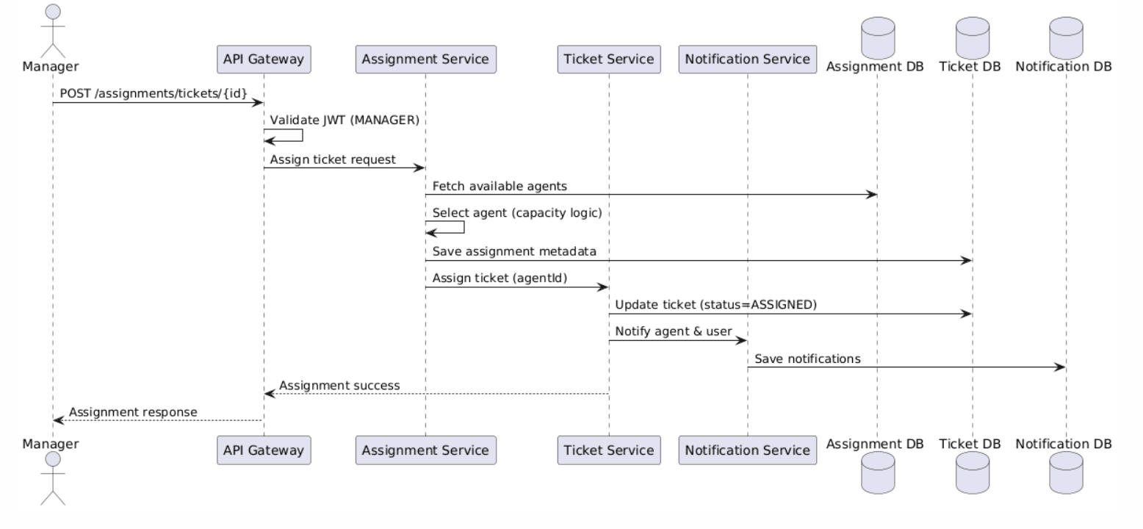

Agent Resolves Ticket -
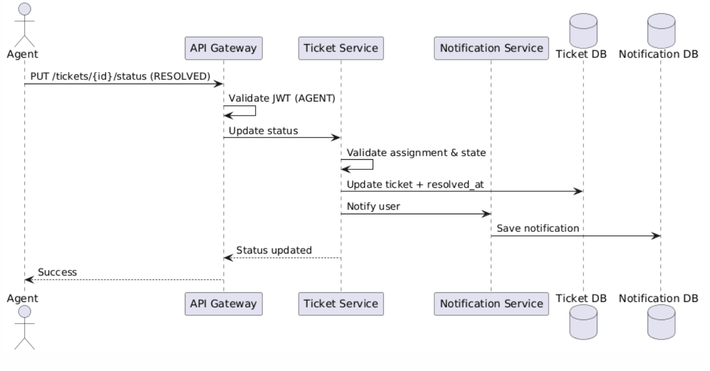2. User Login — Sequence Diagram
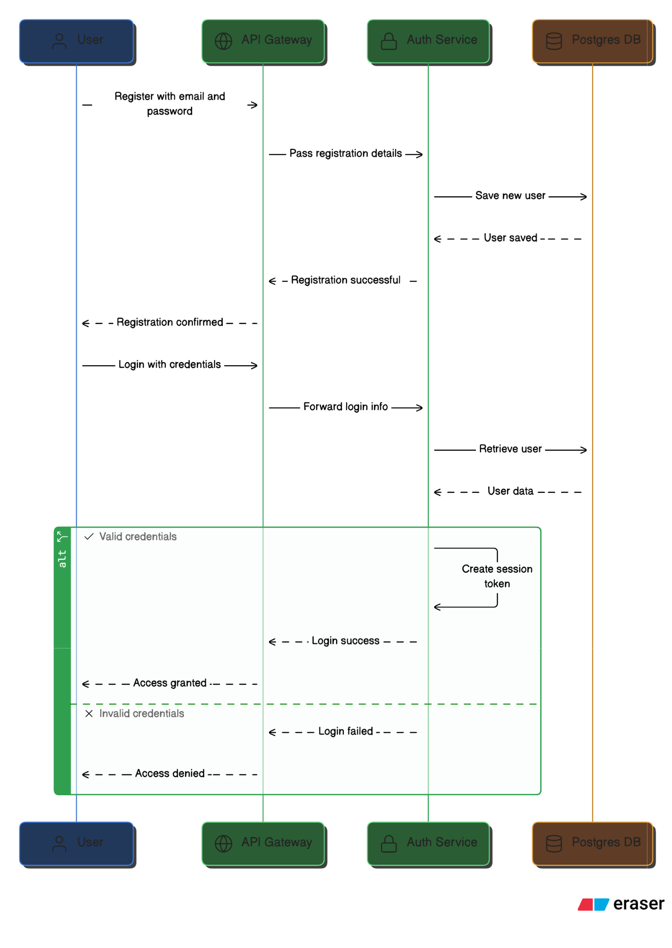

Scenario
Registered user logs into the system.
Flow
- User submits login form
- Angular calls POST /users/login
- User Service fetches user from mysql
- Password is verified
- JWT token generated
- Response sent to Angular
- Angular stores token and navigates user
Participants
- User
- Angular UI
- User Service
- MySql
Failure Cases
- Invalid credentials → 401
- Inactive user /Forbidden → 403

ER Diagram
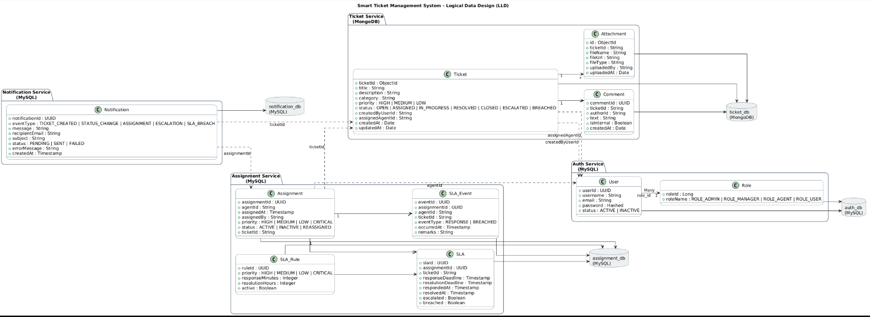
Business Rules check them clearly

1.1 Ticket Creation Rules
Rule BR-001: Public User Can Create Tickets
- User must have END_USER role
- User must be active (is_active = true)
- Title: 5-100 characters
- Description: 10-100 characters
- Must select valid category
Rule BR-002 Assign
Ticket assigned based on no of active breached and escalated tickets by the manager
- If agent inactive then we cannot assign ticket
- If no agent available, mark as unassigned
Rule BR-005: Valid Status Transitions
Status Definitions:
- OPEN: Newly created, awaiting assignment
- IN_PROGRESS: Agent is working on it
- RESOLVED: Agent has fixed the issue
- CLOSED: Customer confirmed resolution
- REOPENED: Customer confirmed issue still exists
Rule BR-006: Status Change Notifications
- OPEN → IN_PROGRESS: Notify assigned agent
- IN_PROGRESS → RESOLVED: Notify ticket creator
- RESOLVED → CLOSED: Notify ticket creator
- CLOSED → REOPENED: Notify assigned agent & manager
Rule BR-007: Reopen
- Manager, Agent , admin will be able to reopen the tickets

1.3 Assignment Rules
Rule BR-008: Assignment Restrictions
- Cannot assign to END_USER (only AGENT can be assigned)
- Cannot assign to inactive user
- Cannot assign already-assigned ticket without unassigning first
- Only MANAGER or ADMIN can assign tickets
Rule BR-009: Reassignment Tracking
- Notify userabout reassignment
- Purpose: Identify problematic tickets

1.4 Comment & Attachment Rules
Rule BR-011: Internal Comments
- Internal comments only visible to support staff (AGENT, MANAGER, ADMIN)
- Customers cannot see internal comments
- Mark with isInternal = true flag
Rule BR-012: Comment Editing/Deletion
- Only comment author or ADMIN can edit
- Once Ticket Closed no comments allowed
Rule BR-013: Attachment Constraints
- Maximum 10 MB on attachment
- Allowed types: PDF, Image (JPG, PNG), Word, Excel, Text
- Blocked types: .exe, .bat, .sh, .jar, .dll

2. SLA RULES (Service Level Agreements)

Priority | Response Time | Resolution Time | Escalation / Breach
HIGH | 30 minute | 8 hours | If not responded in time /not resolved in time
MEDIUM | 60 minutes | 16 hours | If not responded in time /not resolved in time
LOW | 120 minutes | 24 hours | If not responded in time /not resolved in times

5. ESCALATION RULES

Rule ESC-001: Manual Escalation by Agent
- When: Agent cannot resolve and needs help
- Who: AGENT or MANAGER
- Target: Agent/manager
- Reason: Required (free text)
- Notification: Immediate to target manager
- Action: Manager may reassign or suggest in comments

